**Experiment 3**

**PART A**

**A.1 Aim**

*To implement heuristic principles on the designed webpages.*

**A.2 Prerequisite**

Understanding of basic knowledge of designing rules and implementation of website designing.

**A.3 Outcome**

After experimentation, students will be able:

* To understand the importance of designing rules for good interfaces
* To understand the concepts of heuristic principles for interaction process

**A.4 Theory**

A heuristic principle is usability inspection methods for computer software that helps to identify usability problems in the user interface (UI) design. It specifically involves evaluators examining the interface and judging its compliance with recognized usability principles.

1. **Visibility of system status**

The system should always keep users informed about current state and actions through appropriate visual cues and feedback within reasonable time.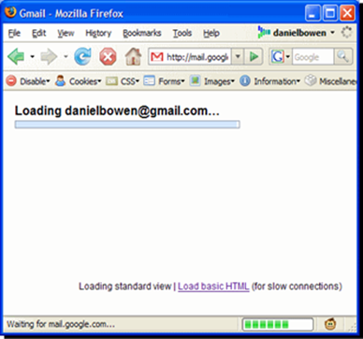

# Match between system and the real world

The system should speak the users’ language, with words, phrases and concepts familiar to the user, rather than system-oriented terms.



iBooks iPad application using the metaphor of wooden book shelf.

**3. User control and freedom**

Users often choose system functions by mistake and will need a clearly marked “emergency exit” to leave the unwanted state without having to go through an extended dialogue. Support undo and redo.

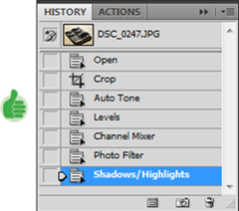

History in Photoshop helps user in recovering previous steps.

**4. Error prevention**

Even better than good error messages is a careful design which prevents a problem from occurring in the first place. Either eliminate error-prone conditions or check for them and present users with a confirmation option before they commit to the action.

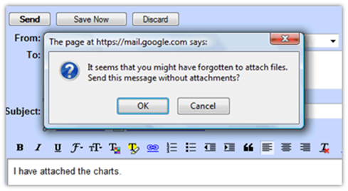

**5. Help users recognize, diagnose, and recover from errors**

Error messages should be expressed in plain language (no codes), precisely indicate the problem, and constructively suggest a solution.

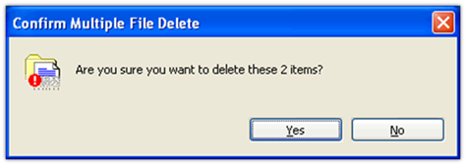

**6. Consistency and standards**

Users should not have to wonder whether different words, situations, or actions mean the same thing.



Inconsistent Icons.

**7. Recognition rather than recall**

Minimize the user’s memory load by making objects, actions, and options visible. The user should not have to remember information from one part of the dialogue to another. Instructions for use of the system should be visible or easily retrievable whenever appropriate.

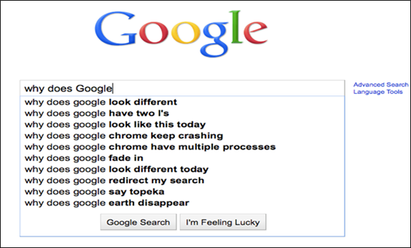

**8. Flexibility and efficiency of use**

Accelerators --unseen by the novice user --may often speed up the interaction for the expert user such that the system can cater to both inexperienced and experienced users. Allow users to tailor frequent actions.

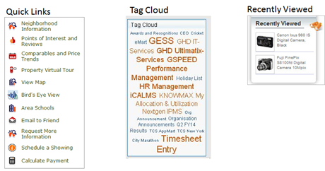

Auto-fills

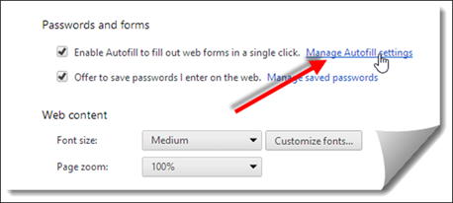

**9. Aesthetic and minimalist design**

Dialogues should not contain information which is irrelevant or rarely needed. Every extra unit of information in a dialogue competes with the relevant units of information and diminishes their relative visibility.

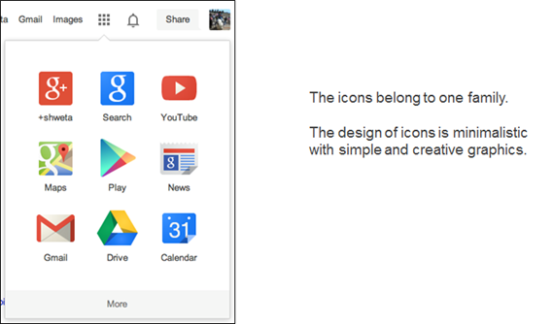

**10. Help and Documentation**

Even though it is better if the system can be used without documentation, it may be necessary to provide help and documentation. Any such information should be easy to search, focused on the user's task, list concrete steps to be carried out, and not be too large.

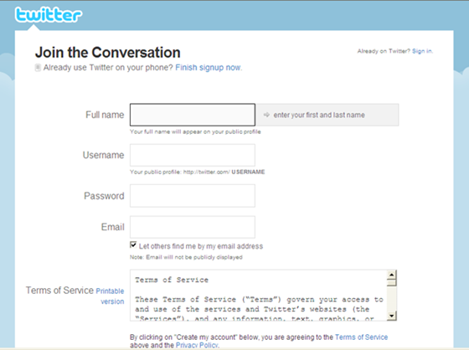

Contextual help is the best way to help !  
Also, telling users about the consequences of their actions is also very helpful.

**A.5 Tasks to perform**

1. Visit the following links to understand real analysis of heuristic principles

<https://uxdesign.cc/heuristic-evaluation-of-bigbasket-application-4a69f43be47d>

<https://medium.com/@rtmdeb/heuristic-evaluation-ux-case-study-grofers-com-website-a50e2d475393>

2. Consider your previous project (website/app) and mark and  symbols in the following heuristic principles table wherever is applicable in designed project

| **Heuristic Principles** | **Mark  and** | **Reason where Heuristic principles is applicable** |
| --- | --- | --- |
| 1. Visibility of system status |  |  |
| 1. Match between system and the real world |  |  |
| 1. User control and freedom |  |  |
| 1. Consistency and standards |  |  |
| 1. Error prevention |  |  |
| 1. Recognition rather than recall |  |  |
| 1. Flexibility and efficiency of use |  |  |
| 1. Aesthetic and minimalist design |  |  |
| 1. Help users recognize, diagnose, and recover from errors |  |  |
| 1. Help and documentation |  |  |

**(PART - B)**

(TO BE COMPLETED BY STUDENTS)

(Students must submit the soft copy as per following segments within two hours of the practical)

| Roll.No. : | Name: |
| --- | --- |
| Sem/Year : | Batch: |
| Date of Experiment : | Date of Submission: |
| Grade -- |  |

**B.1: Output of performed tasks**

1: Paste the screen shots or provide project link of developed webpages/app.

2: Paste the table of task 2 and give the proper reason wherever heuristic principles are applicable or not. Students are supposed to paste the screenshot wherever is applicable.

**B.2: Observations and Learnings:**

Write down the possible improvements to the interface based on your web interaction

**B.3: Conclusion:**

(Students must write the conclusion as per the attainment of individual outcome listed above and learning/observation noted in section B.2)